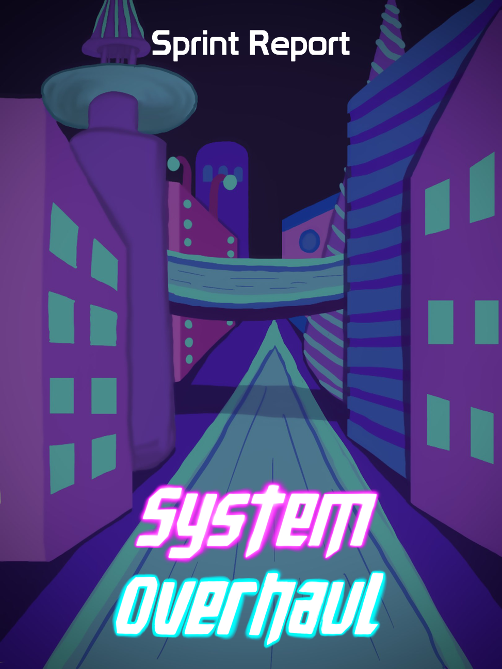





**Table of Contents**

**Previous Week** **2**

Sprint Backlog 2

Review 2

**Next Week** **3**

Sprint Backlog 3

Notes 3

# Previous Week

## Sprint Backlog

| **Tasks** | **Time Needed** | **Responsible** | **Priority** | **Stage** |
| --- | --- | --- | --- | --- |
| Combine Code | ½ Day | All | Urgent | Completed |
| Create City | 2 Days | All | Urgent | Completed |
| GDD - 3rd Delivery | 3 Days | All | High | Completed |
| Presentation Slides - 3rd Delivery | 1 Day | All | High | Completed |
| Delivery Report - 3rd Delivery | ½ Day | All | High | Completed |
| Instructions - 3rd Delivery | ½ Day | All | High | Completed |
| Spec Sheet - 3rd Delivery | 1 Day | All | High | Completed |
| Trailer - 3rd Delivery | 1 Day | Designers | High | Completed |
| Production Plan - 3rd Delivery | ½ Day | All | High | Completed |

* 1. Objectives

All of our objectives were completed successfully.

No tasks were planned from the design part.

## Review

All of the tasks were done successfully and were finished in time.

This week is the 3rd delivery.

Next week is the 3rd delivery presentation.